Lovely Professional University

Football Player Performance Analysis and Prediction using Linear Regression

Submitted by:
Harsh Bhardwaj
Submitted to:
Mr. Madhav Dubey
Acknowledgments
I would like to express my heartfelt gratitude to everyone who contributed to the
successful completion of this project on Football Player Performance Analysis
& Prediction.
First and foremost, I extend my sincere thanks to Mr. Madhav Dubey for their invaluable
guidance and support throughout this research. Their insights, feedback, and encouragement have been instrumental in shaping the direction of this project.
I am also thankful to the data providers and organizations that made the data available,
including football performance databases and other relevant sources.
Finally, I acknowledge the role of open-source tools such as Python, Jupyter Notebook, Pandas, Seaborn, Matplotlib, Scikit-learn, and SciPy, which played a crucial role in data analysis, modeling, and visualization throughout the project.
This project has deepened my understanding of football analytics and machine learning in sports, and I hope it contributes to advancing the field of performance prediction for football players.
Thank you.

Chapter 1

Introduction
Football is a world sport with millions or even billions of fans around the world, footballers being some of the most famous people on the planet. Each player has the potential to change the outcome of a game and success of their team as a whole. Understanding and predicting a player's performance based on various metrics can provide valuable insights to the coaches, analysts and even to the team management. This project is about analysing a football player's performance and predicting their future results, taking into account various attributes such as physical conditions and game stats.
The capability of predicting a player's future results precisely is very important for teams, their managers and coaches for making informed decisions about player recruitment, match strategy, etc. This project will be helpful in doing these tasks through analysing player stats and using models to predict their future performance.

Motivation for Problem Statement
I have always been a huge fan of football from my early childhood. I am very big admirer of the world-renowned Portuguese footballer Cristiano Ronaldo. Predicting the goals he will score in the upcoming season has always been exiting. When I started studying Data Science in my Bachelors, I was told to make a term project for the semester. So, I chose the topic of Football as I could finally predict a players future season's performance based on their previous season stats.
The motivation behind this project is to use raw performance data and make meaningful predictions. By analysing patterns and trends in a player's statistics, I hope to create a model that can provide insights into upcoming season performance of players.

Why this study is Important?

In the world of professional football, where the stakes are always high, every decision made is crucial. Whether it being selecting the players for an important game, signing a new player or even just determining the future potentials of the current players. Having a proper method to analyse and predict a player’s performance would provide teams with an advantage.
This project is necessary because it doesn’t only focus on the player’s past performances, but also aims to build a predictive model that can forecast how a player might perform in the upcoming season/games. With proper tools, teams can make use of these predictions to make better strategies, better training plans, etc.

Goals of this Project

The primary goal of this project is analysis of player performance across a season/seasons and develop a predictive model using these statistics. By using old data and applying statistical techniques, I am to:
- Analyse player performance using different metrics such as goals, assists, playtime, fouls, etc.
- Identify key indicators that significantly affect player performance.
- Develop a predicting model that forecast player performance for future seasons.
- Provide actionable insights.

Data Collection

For this project, the data was collected from Excell4Soccer, a platform that provides detailed statistics on football player performances. The data includes information about different player attributes such as goals scored, assists, total shots, playing time, disciplinary actions (yellow and red cards), etc.
The data collected incudes:
- Historical Match Data: Player Stats for Premier League players across 3 different seasons.
- Player Performance Metric: Key statistics like goals, assists, shots, playtime, and disciplinary records.
This data is cleaned, processed, and integrated into a usable format to ensure it’s accuracy for analysis.

Chapter 2: Dataset Preprocessing

Data Preprocessing is a very important step in any data analysis or ML project. It involves preparing the data and cleaning it to make sure that the dataset is ready for analysis or modelling. This step includes several sub-steps like Data Cleaning, Feature Engineering and Data Transformation. These sub-steps help in removing inconsistencies, modify the dataset structure, and ensure it aligns with the modelling requirements.

Data Cleaning

Data cleaning is the process of identifying missing values, outliers, unnecessary data or incorrect entries and rectifying these issues. It makes sure that the data is consistent and reliable before moving further with the analysis.
In this project, the dataset had some columns with missing values, which needed to be addressed. The cleaning process was carried out using the following steps:
- Identifying Missing Values:
The dataset was examined for missing values using a function .isnull().sum() which sums up the total missing values in each column in the dataset.

- Imputing Missing Values:
- For columns Weight and Height, the missing values were filled using the median values of the respective column since it is not an outlier. The function .fillna() was used with the arguments passed as the function .median().
- For the Offsides column, where missing values could indicate that no offsides were committed by the player, missing value was filled with 0 with .fillna() function with argument as 0.

- Dropping Unnecessary Columns:
The Update Time column was removed as it didn’t contribute to the analysis using the .drop() function.

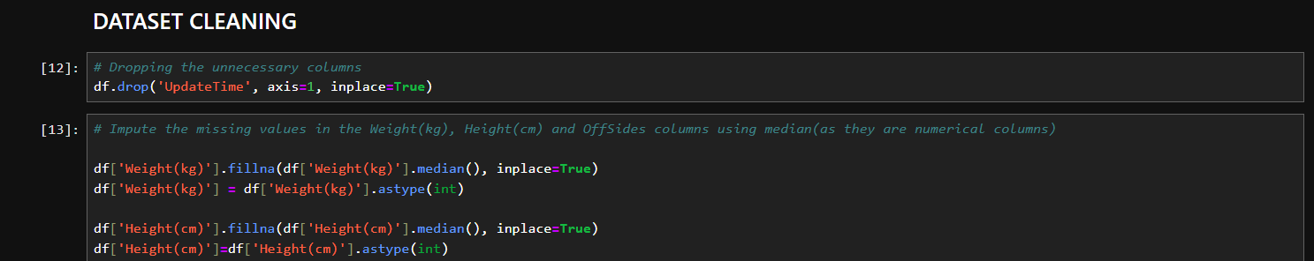

Feature Engineering

Feature Engineering involves creating new features using the old ones or modifying the existing ones to improve the model performance.
In this project, I have done the following steps:
- Goals per Match:
Made a new feature using the existing feature Total Goals and Appearances. If the Total Goals row value is 0, then it is set to 0, otherwise the values comes out to be Total Goals/Appearances. The .apply() function was used with a lambda function as it’s attribute.

- Shot Accuracy:
Another feature was made using the Total Shots and Shots on Target columns. If either of the values are 0, then the feature value becomes 0, otherwise the value is Shots on Target/Total Shots. The .apply() function was used with a lambda function as it’s attribute.

- Age Group Categorization:
Players were categorized into 3 age groups based on their age: Young (<25), Mid-aged (25 to 33) and Old (>33). A user-defined function age_categorize() was made where Age was passed as parameter.

- Goalkeeper Accuracy:
A new feature was made to measure the save accuracy of goalkeepers. The columns Goals Conceded and Shots Faced were used where the value is set to 0 is the Shots Faced row is 0, or else the value comes out to be Goals Conceded/Shots Faced. The .apply() function was used with a lambda function as it’s attribute.

- Defensive Player Features:
Two defensive player features were made Fouls Involvement (Fouls Committed + Fouls Suffered) and Total Cards (Yellow cards + Red cards). The .apply() function was used with a lambda function as it’s attribute.

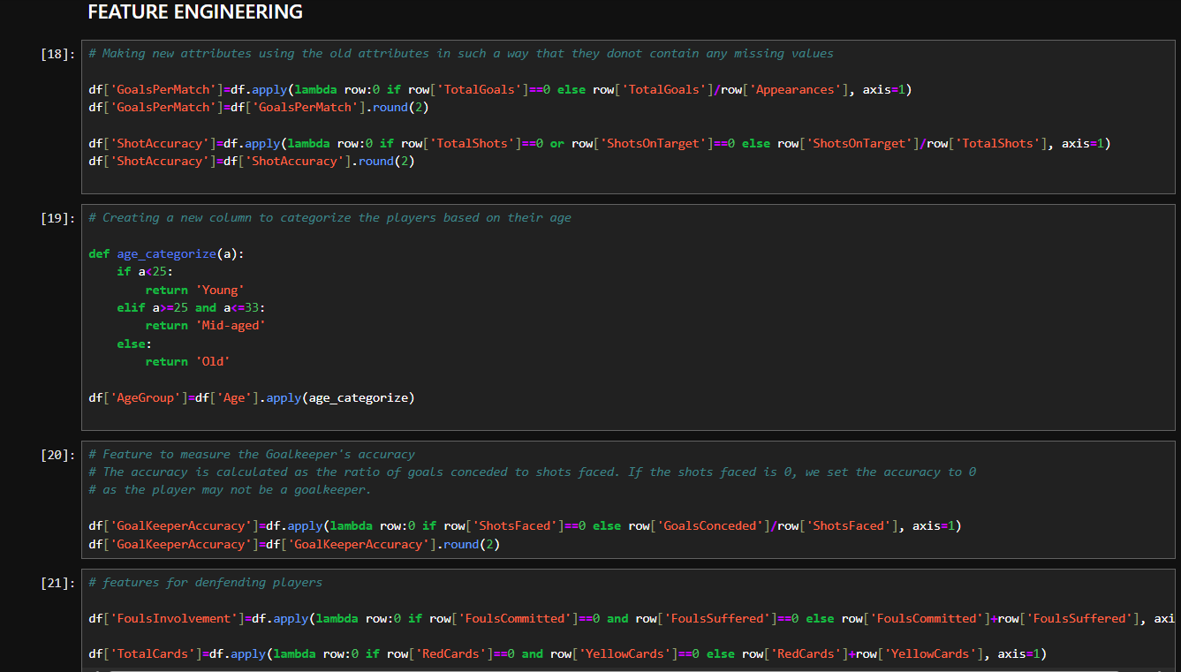

Data Transformation

Data transformation is about converting data into a format that can be used more effectively in data analysis and modelling process. This step ensures that the data is standardized and normalized to meet assumptions of ML algorithms.
In this project, the main data transformation involved was:
- Data Type Conversion:
The Weight and Height columns were explicitly converted from float64 data type to int64 data type. This was dome after imputing the missing values.

Chapter 3: Exploratory Data Analysis

Exploratory Data Analysis (EDA) is an essential process for understanding the structure, patterns, and relationships within a dataset. Before diving into modelling techniques, it is crucial to comprehend the dataset's characteristics through a variety of methods, including summary statistics and visual exploration.

Dataset Description

Dataset Description is basically the information of the dataset that we can infer just after importing the dataset. It includes columns description, shape of the dataset, etc.
In this project, the dataset includes football player performance data across 3 different seasons of the Premier League. The deeper understanding of the data, the dataset description is:
- Column Description (27 columns):
- Id: A unique identifier for each player.
- Name: The name of the football player.
- Season: The football season during which the data was recorded (e.g., 2022-2023, 2023-2024).
- Weight(kg): The weight of the player in kilograms.
- Height(cm): The height of the player in centimeters.
- Age: The age of the player during the respective season.
- Citizenship: The country of citizenship of the player.
- Team: The football team the player is associated with.
- Jersey: The jersey number of the player.
- Position: The position the player occupies on the field (e.g., Goalkeeper, Defender, Midfielder, Forward).
- Appearances: Total games played by the player during the season.
- GoalAssists: Total assists made by the player in the given season.
- ShotsOnTarget: Total shots on target made by the player, i.e., shots that would have resulted in goals if not for the goalkeeper's intervention.
- TotalShots: Total number of shots taken by the player during the season.
- OffSides: Total number of offsides committed by the player during the season.
- YellowCards: Total number of yellow cards received by the player during the season.
- RedCards: Total number of red cards received by the player during the season.
- ShotsFaced: Total number of shots faced by the player (relevant for goalkeepers).
- GoalsConceded: Total number of goals conceded by the player during the season (relevant for goalkeepers).
- TotalGoals: Total number of goals scored by the player in the given season.
- TotalPlayTime: Total number of minutes played by the player during the season.
- AveragePlayTime: Average number of minutes the player spent on the field per match.
- OwnGoals: The number of goals scored by the player on his own team.
- FoulsCommitted: Total number of fouls committed by the player during the season.
- FoulsSuffered: Total number of fouls suffered (committed against the player) during the season.
- SubIns: Total number of times the player was subbed in in place of another player.
- UpdateTime: The timestamp indicating when the data was last updated.

- Size/Shape of the Dataset:
The size or shape of the dataset is (800, 27). I was calculated using the .shape function.

Statistical Summary

After loading the dataset, we compute important statistical summaries to see the distribution of values in numerical columns. This is done using the .describe() function. The various basic statistics such as mean, standard deviation, and quartiles are calculated for the numerical columns. Some of the results are:
- Weight(kg):
Average weight of players is 75.25 kg, with values from 54 kg upto 94 kg.
- Height(cm):
Average height is about 182.5 cm, with a minimum height being 163 and maximum height 201 cm.
- Age:
The average age is nearly 27 years, with least being 17 and the oldest being 39 years.
- Appearances:
On an average, players played in 20 matches, with some players playing 0 matches and others playing 38.
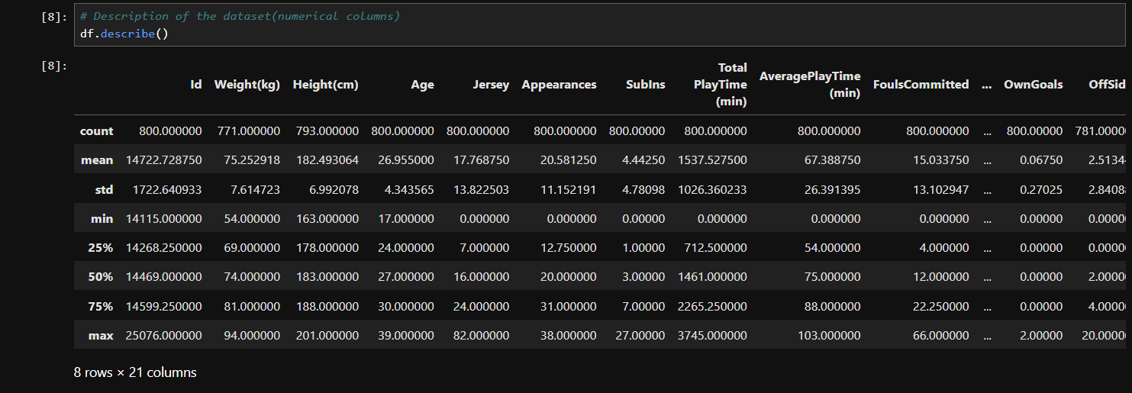

Visualizations

Visualizations or simply put, plots, are made using libraries like seaborn and matplotlib which further aid in deep understanding and gaining insights about the dataset. There are various types of visualizations such as bar plots, histograms, pie charts, box plots, violin plots, correlation maps (heatmaps), etc.
In this project, we have made various number of charts using the cleaned and modified dataset. Some of them are:
- Distribution of Player Age:
A histogram with a KDE line was plotted to show the distribution of player’s ages.

- Distribution of Players by Position:
A count plot was used to show how many players are there for each position.

- Total Goals Scored per Team:
A bar plot was used to show the total number of goals scored by each team.

- Goals Per Match Across Different Age Groups:
A violin plot was used to explore how players in different age groups (Young, Mid-aged and Old) performed in terms of the GoalsPerMatch feature.

- Card Distribution Across Age Groups:
A stacked bar plot was created to visualize the number of yellow and red cards received by players across different age groups.

- Top 15 Players with Most Appearances:
A combined bar plot (with line plot) was used to visualize the top 15 players with the highest total appearances across all seasons.

- Correlation Heatmap for some Important Features:
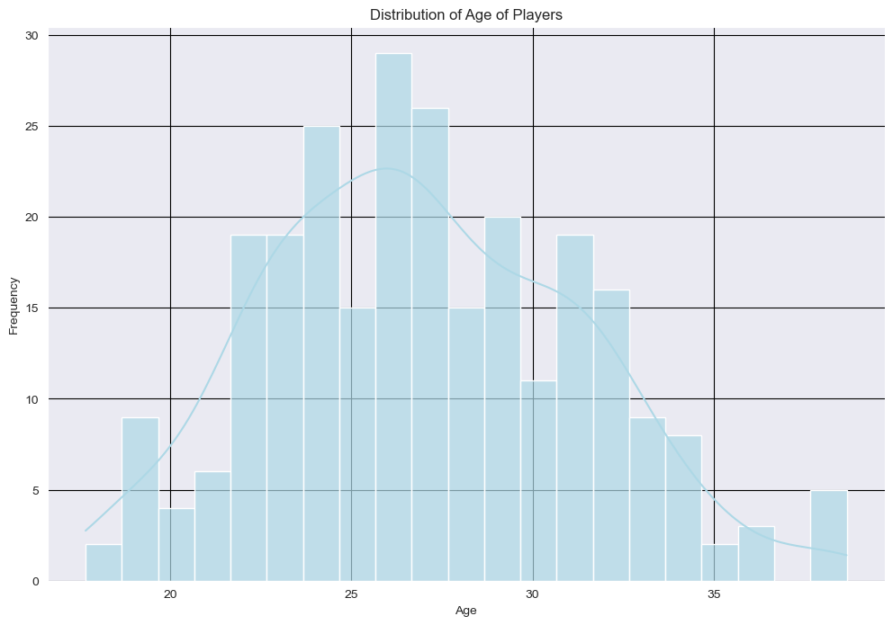
A heatmap was made using the correlation matrix for some of the most important features in the dataset.
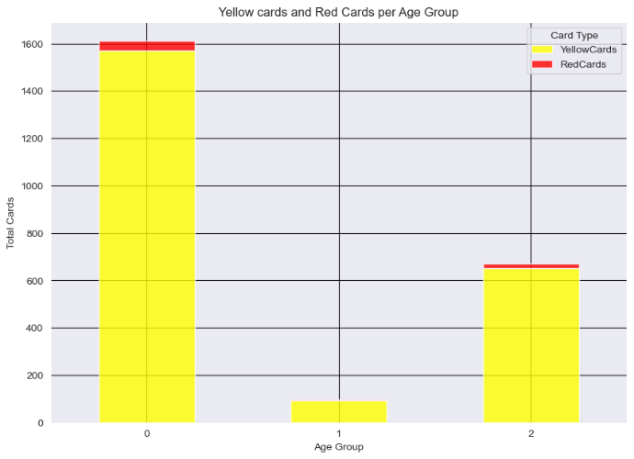
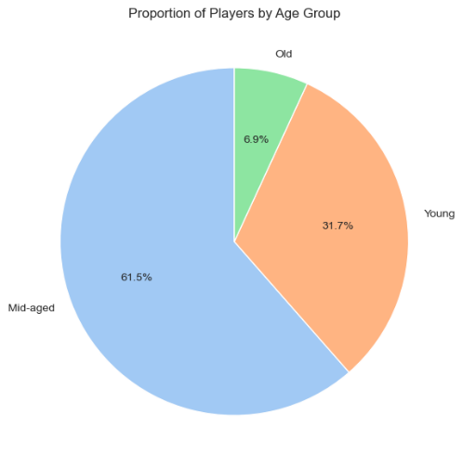
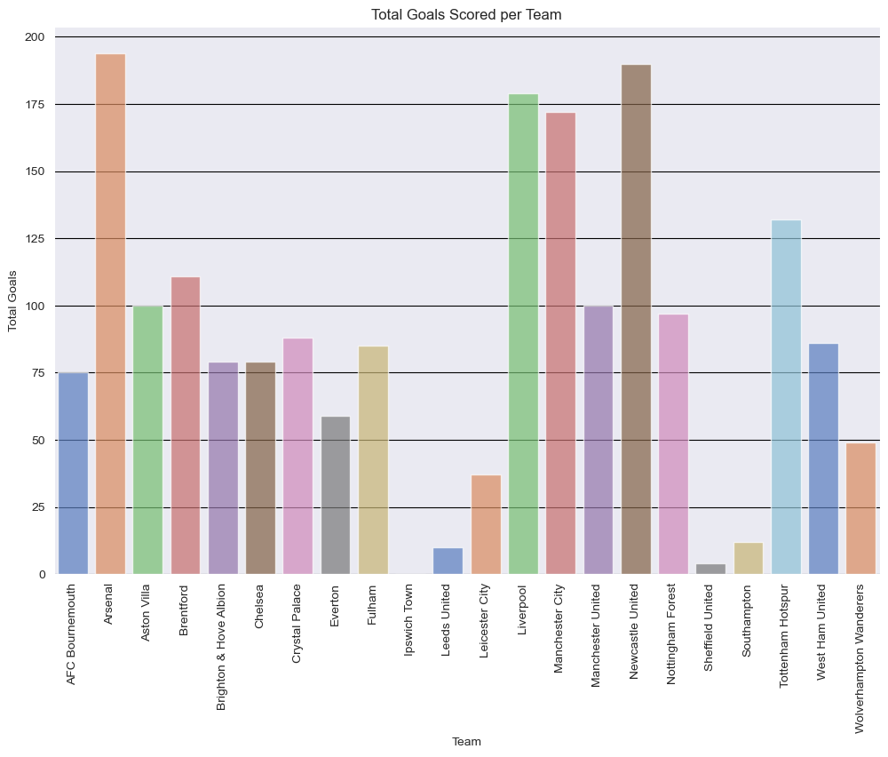
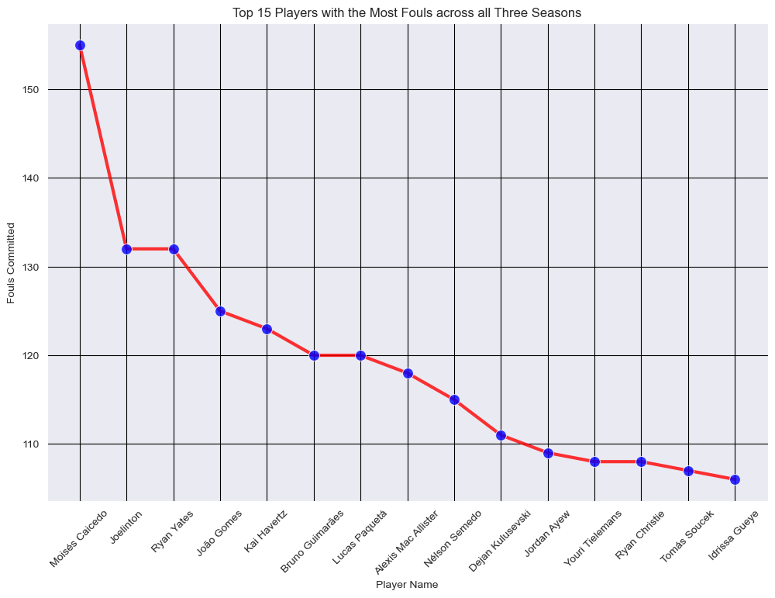
Chapter 4: Statistical Testing (Hypothesis)

A statistical hypothesis test is a method of statistical inference used to decide whether the data provide sufficient evidence to reject a particular hypothesis. A statistical hypothesis test typically involves a calculation of a test statistic.
In this project, we mainly focus on three statistical tests i.e. T-test (2 sample), Chi-square test and ANOVA test.

T-Test (2-Sample)

A T-test is a hypothesis testing method used to compare the means of two groups to determine if there is a significant difference between them.
Why is it used?
The T-test is used when we have two groups and we want to know whether the means of the 2 groups differ very much. In our situation, it can be used to compare the performance of different positions or teams.
Assumptions in T-test:
- The data is normally distributed.
- The variances of the two groups being compared are equal.
- The samples are independent.
Assumptions for our Dataset:
- For the T-test in this project, we compared the Shot Accuracy between Forwards and Midfielders.
- The dataset was filtered to extract the Shot Accuracy data for the two player positions.
- Normality: The Shot Accuracy values for both positions were normally distributed.
- Independence: The player data of Forwards and Midfielders are independent, as they are different positions.

T-test Execution (2 done, giving example of 1):
- Null Hypothesis (H₀): The mean shot accuracy of Forwards and Midfielders is the same.
- Alternative Hypothesis (H₁): The mean shot accuracy of Forwards and Midfielders is different.
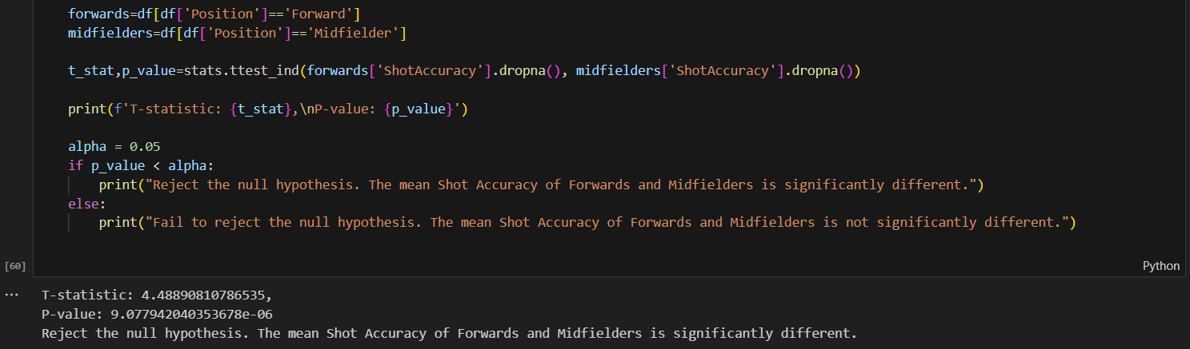
Results:
- T-statistic: 4.49
- P-value: 9.08e-06
- Since the P-value is less than 0.05, we reject the null hypothesis and infer that there is a significant difference in the shot accuracy of Forwards and that of Midfielders.

Chi-Square Test

Chi-Square Test is a hypothesis testing used to decide if there is a notable association between two categorical variables or data.
Why is it used?
This test is useful when comparing categorical/object data, such as in our case, examining the relationship between player Position and Age Group.
Assumptions for Chi-Square Tesr:
- The data consists of categorical variables.
- Observations should be independent.
- The sample size should be large enough to expect at least 5 observations per cell in the contingency table.
Assumptions in Our Dataset:
- Position and Age Group are categorical variables and the observations are independent.
- The contingency table was created between these two variables, and the Chi-Square test was applied to assess if the distribution of player positions differs across age groups.
Chi-Square Test Execution ():
- Null Hypothesis (H₀): There is no association between Position and Age Group.
- Alternative Hypothesis (H₁): There is an association between Position and Age Group.
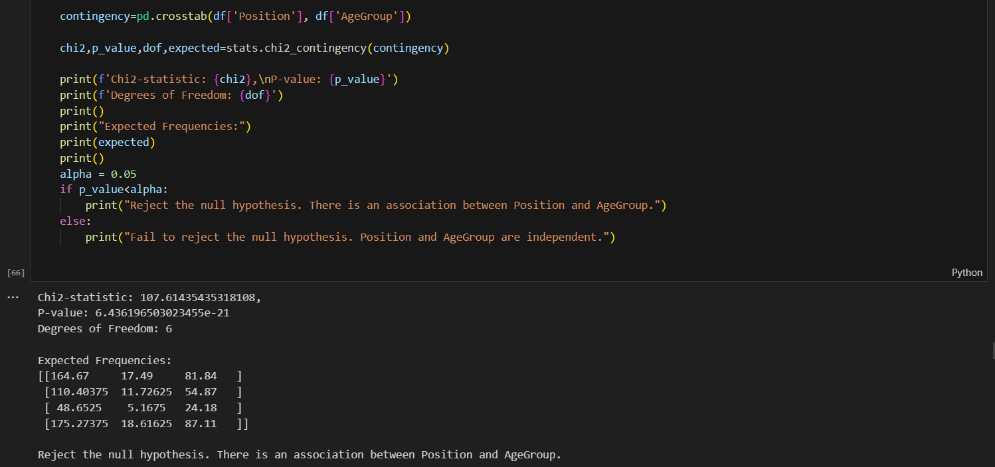
Results:
- Chi2-statistic: 107.61
- P-value: 6.44e-21
- Degrees of Freedom: 6
- Since the P-value is much smaller than 0.05, we reject the null hypothesis.

ANOVA (Analysis of Variance) Test

ANOVA is a hypothesis testing method used to compare means between more than two groups. It helps us determine if there is a significant difference in the means between multiple groups.
Why is it used?
ANOVA is used when comparing the means of three or more groups. In my project, ANOVA can be applied to compare the appearances or shot accuracy across different positions (e.g., Forward, Midfielder, Goalkeeper).
Assumptions for ANOVA:
- The groups are independent.
- The data in each group is normally distributed.
- The variances across groups are approximately equal (homogeneity of variances).
Assumptions in Our Dataset:
- Positions are independent groups.
- Appearances or Shot Accuracy are continuous variables.
- We conducted a One-Way ANOVA to test if there is a significant difference in Appearances across different positions.
ANOVA Execution:
- Null Hypothesis (H₀): There is no significant difference in the number of Appearances across the positions.
- Alternative Hypothesis (H₁): There is a significant difference in Appearances across the positions.
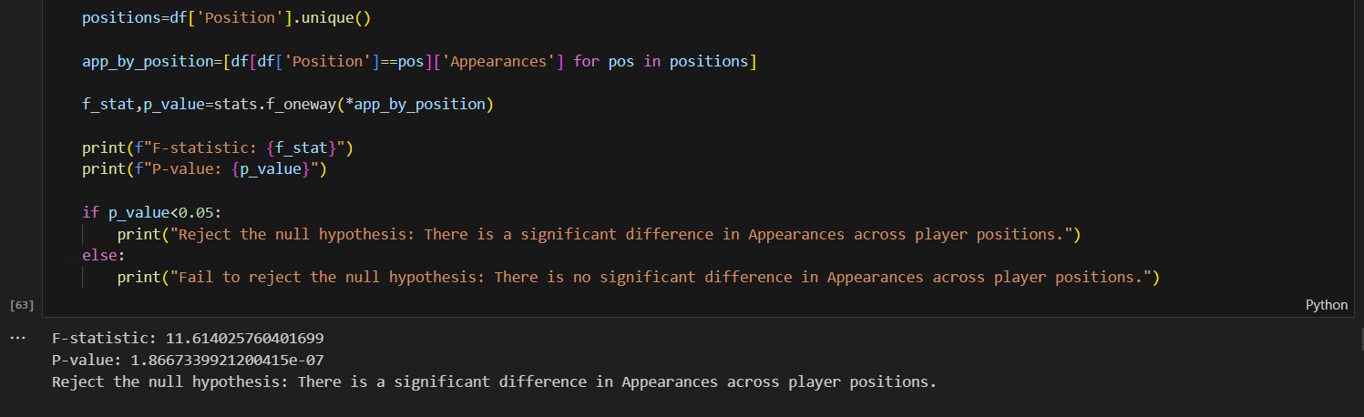
Results:
- F-statistic: 11.61
- P-value: 1.87e-07
- Since the P-value is less than 0.05, we reject the null hypothesis and conclude that there is a significant difference in Appearances across player positions.

Chapter 5: Predictive Modelling (Linear Regression)

Predictive modelling using Linear Regression is used to analyse and predict trends in football player performance. Predictive modelling allows us to use past data and generate good forecasts about the future results. Through the use of linear regression models, we strive to forecast metrics such as Total Goals and Goals Conceded by analysing different player attributes.

Model Selection (Linear Regression)
Linear regression is a statistical technique used to model the relationship between one dependent variable and one or more independent variables. The goal of linear regression is to fit a linear equation to the data that best predicts the dependent variable from the independent variables.
Why Linear Regression for this Dataset?
In this project, I selected Linear Regression because it is perfect for predicting continuous variables like Total Goals and Goals Conceded on the basis of player stats such as Shots, Fouls Involvement, Shot Accuracy, and Age.

Model Training and Evaluation
Training the Model
The Linear Regression model was trained on using the following features:
- Independent Variables (X): Age, TotalShots, FoulsInvolvement, GoalsPerMatch, ShotAccuracy, YellowCards, RedCards, Height(cm), and Weight(kg).
- Dependent Variable (y): TotalGoals.
We split the dataset into a feature matrix (X) and the target variable (y). The model was then trained using this data to understand the relationship between the features and the target variable.
Results:
- R-Squared: 0.93
- Mean Squared Error: 1.16
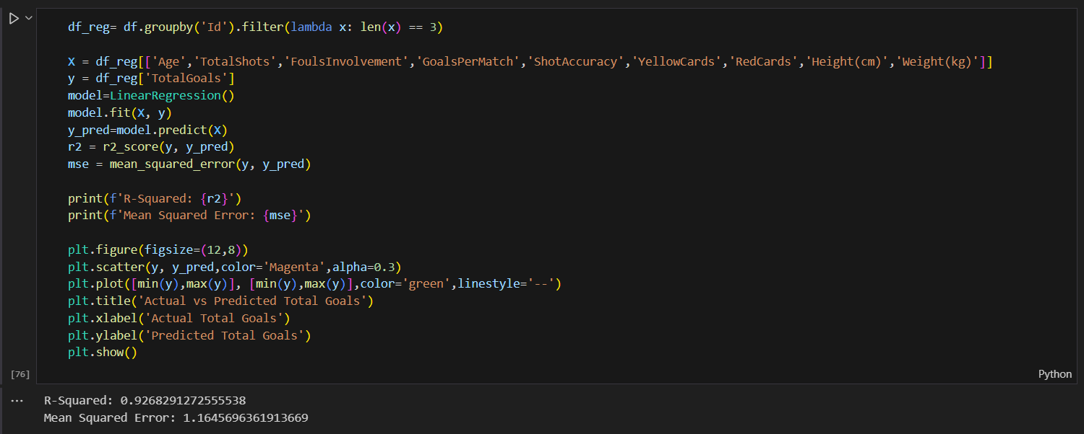
These results indicate that the model explains 93% of the variance in Total Goals, which is a strong fit. The Mean Squared Error (MSE) of 1.16 indicates the average error between predicted and actual values is quite small.

Forecasting Future Trends
Predicting Future Performance
Once the model is trained, it is used to predict the performance of players for the 2025-2026 season. The model was applied to the player data for the upcoming season to forecast how many goals players are likely to score based on their performance in previous season.
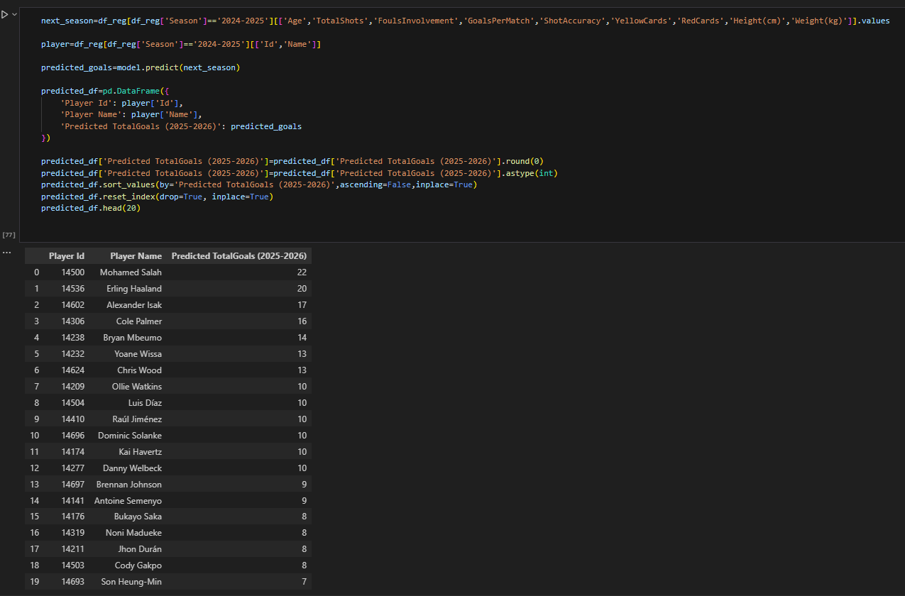
Visualization of Predicted Trends
We also visualized the actual vs. predicted goals to better understand the model's performance.
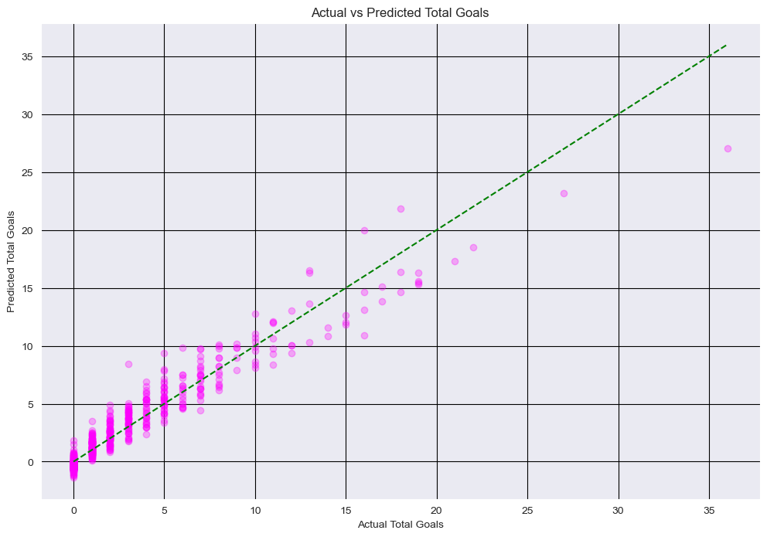

Chapter 6: Conclusions and Future Recommendations

Key Findings
- Player Performance Analysis:
  - Top Performers:
- Using Linear Regression, we successfully predicted the total goals for players, such as Mohamed Salah and Erling Haaland, based on features like Age, Shots, Shot Accuracy, and Goals Per Match.
- The model achieved an impressive R-Squared value of 0.93, indicating that it explains 93% of the variance in total goals scored.
  - Goalkeeper Performance:
- For goalkeepers, we predicted Goals Conceded using features like Shots Faced and Goalkeeper Accuracy.
- The R-Squared value of 0.96 demonstrated that the model could accurately forecast goalkeeper performance.
- Statistical Testing:
  - T-Test:
- A T-test was conducted to compare Shot Accuracy between Forwards and Midfielders.
- The results showed a significant difference, confirming that forwards tend to have higher shot accuracy than midfielders.
  - ANOVA:
- One-way ANOVA was used to assess the difference in Appearances across various player positions.
- The test revealed that there is indeed a significant difference in the number of appearances between different positions (e.g., Forwards, Defenders, etc.).
  - Chi-Square Test:
- The Chi-Square Test showed that Position and Age Group are dependent variables, suggesting that certain positions are more common in specific age groups.

- Visualization:
  - Correlation Matrix:
- A heatmap was used to visualize correlations between key features such as Goals, Shots, Assists, and Yellow Cards.
- We observed positive correlations between Total Shots and Goals and negative correlations between Fouls Committed and Goals Scored.
  - Trends Over Seasons:
- The line plots showed trends such as the average goals per match for Forwards across seasons, and goalkeeper accuracy trends, helping visualize performance improvements or declines over time.
- Predictions:
  - Future Performance:
- Based on the predictive model, we forecasted the top players for the 2025-2026 season, with Mohamed Salah and Erling Haaland predicted to continue their dominant goal-scoring performances.

Recommendations for Future
- Improvement of Data Quality:
  - While the data used in this project was robust, missing values were a challenge, particularly in OffSides and Weight columns. Future datasets should include better data imputation methods or more comprehensive data collection to reduce missing values.
- Incorporating More Advanced Models:
  - While Linear Regression provided good results, more advanced models such as Random Forests, Gradient Boosting Machines (GBMs), or Neural Networks could be explored to capture more complex relationships between variables.
  - Feature Engineering can be extended to include interaction terms or non-linear relationships to further enhance model accuracy.
- Expanded Feature Set:
  - More features such as Player Fitness (e.g., injury data), Team Tactics, or Game Context (e.g., home vs. away) could be included to improve the predictive power of the models.
  - Additionally, incorporating real-time data (such as match performance statistics) could help refine predictions as the season progresses.
- Further Statistical Analysis:
  - Conduct more in-depth statistical tests on different player attributes (such as Dribbling, Pass Completion Rate, etc.) to identify hidden patterns and optimize team selections.
  - Incorporate time-series analysis to track player performance fluctuations throughout the season and adapt player strategies based on performance trends.
- Real-World Application:
  - The model can be integrated into football team management systems, helping coaches and analysts make data-driven decisions regarding player selection, training, and match strategies.

